12 Way Vertically Mounted Rackmount PDU - UK Sockets (PDU-12WS-V)
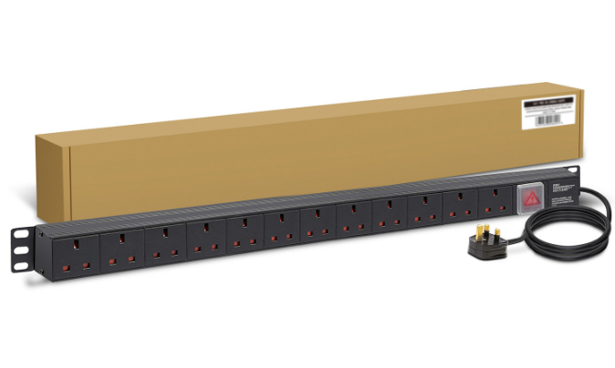

PDU-12WS-V

DESCRIPTION
The LMS Power PDU-12WS-V is a high-quality vertically mounted PDU (Power Distribution Unit) that simply fits within the universal horizontal mounting brackets of data, telecom and server cabinets.
A critical accessory for your data cabinets if you need to provide effective power to devices including Ethernet Switches, Servers, UPS, NAS and of course cabinet accessories including cooling fan trays.
Robust, alloy design complete with rackmount brackets fitted, high-quality Neon Switch and of course UK output sockets together with a high quality, BSI-fitted

13 Amp UK plug.

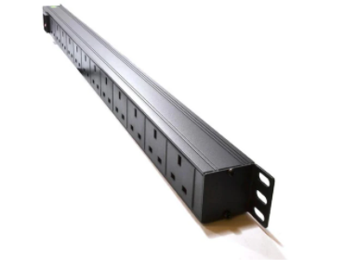

Key Features:
Standard UK 3-Pin power outlets for your appliances
1U vertically mounted attaches to internal profiles
Neon On/Off Rocker switch to prevent accidental turn off
Backed up by LMS Power's exclusive 3-year warranty

SPECIFICATIONS
Warranty LMS Data 3-Year Warranty
Chassis 1U vertical PDU with mounting brackets
Output Sockets 12 UK 3-PIN Sockets
Power Input Fitted UK 3PIN BSI Plug 13 Amp
Flex Length 1.8 metres (approx)
Power Control On/Off Rocker Switch (illuminated)
Power Rating 4000 Watts (approx)

Applications:

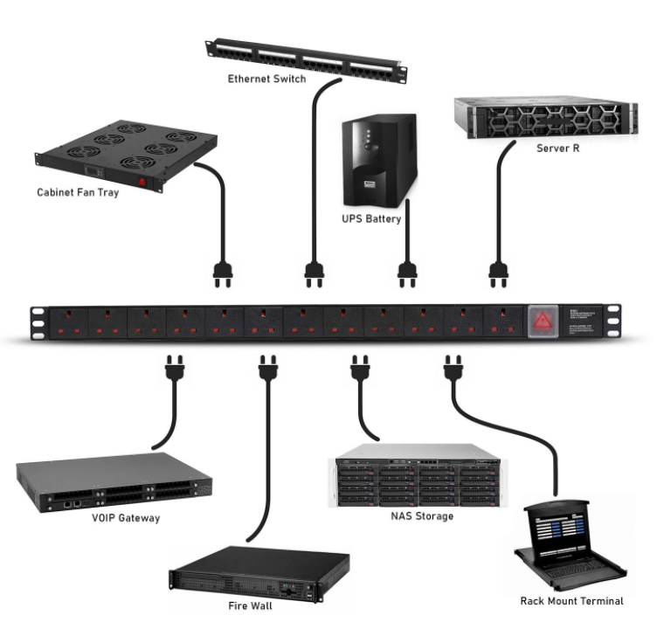
Create instant power feeds to your data, telecom or server cabinets
Provide effective power for cabinet cooling fans, UPS systems
Ideal as stand-alone trailing sockets outside the cabinet

Product Code:
Part Number: PDU-12WS-V
EAN: 8400800035110
Weight: 1.7Kg approx

Supplied With:
PDU-12WS-V 12 Way Horizontal PDU
Cabinet brackets (Fitted)
* Specifications and product design are subject to change. E&OE.

